Before scaling:



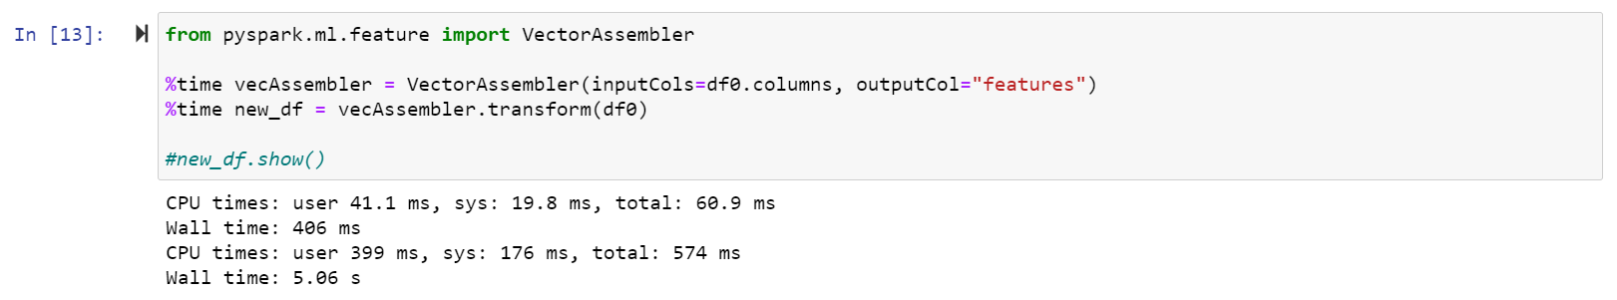

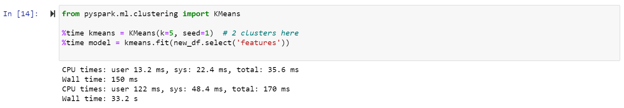

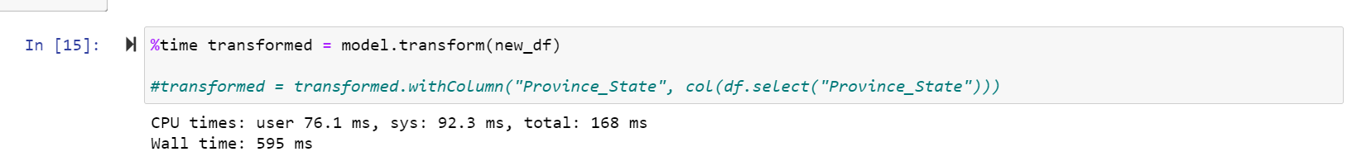

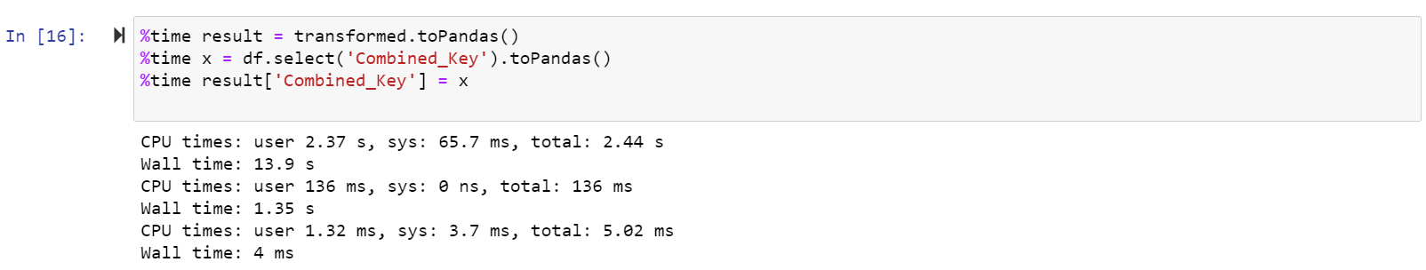

After vertical scaling:

(running on aws ec2 linux machine)



